Organization
Delivery Address
Contact Person
Contact Number
EMAIL
How do you know us? | Searching Engine / Referral / Facebook / Instagram / Others(Please specify)
Our order process | 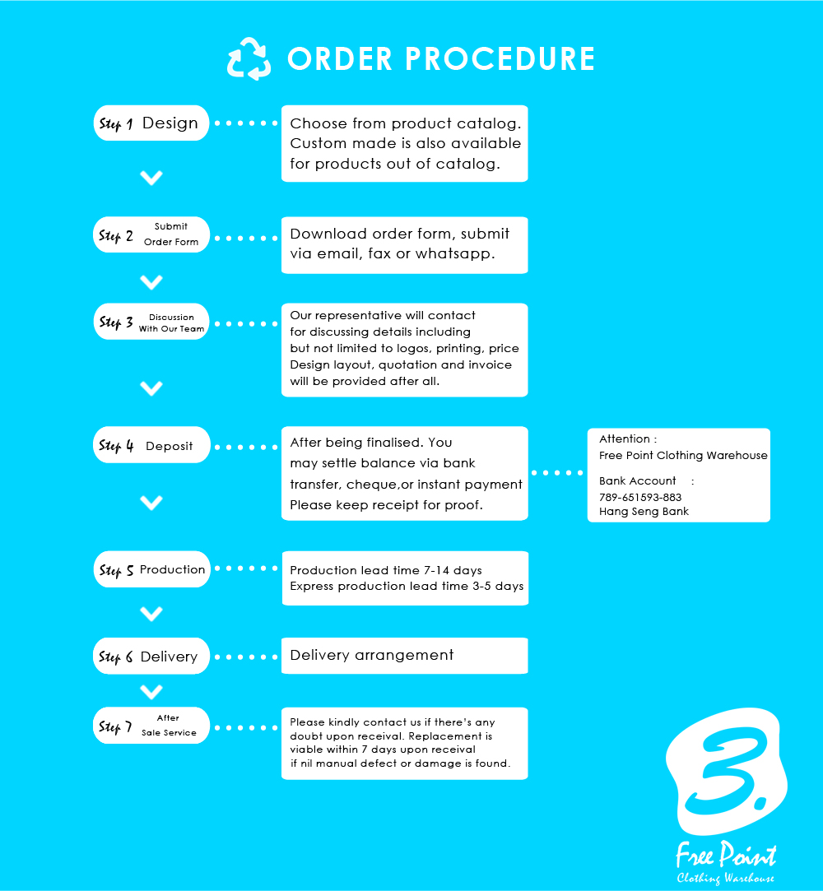

1. General Information

2. Product Order Details
*Please kindly attach the logos with this order form in your email
Product
Logo 1 |  | Position
Logo 2 |  | Position
Logo 3 |  | Position
Logo 4 |  | Position
Remarks (Technics, etc)
*File Format：AI, PSD, JPG, PNG

3. Size Details
XS: | S: | M: | L: | XL: | 2XL:

FAQ
These terms and conditions outline the rules and regulations for the use of FREE POINT CLOTHING WAREHOUSE
- Order
  - Please kindly send us the proof after the payment. Production will take place after our representative confirmation of the payment proof, design layout and order details. Working days will be started counting from the next day of the confirmation. Normally it takes around 7-14 working days, depending on quantity, design and technics required of the order. Please kindly be aware of the lead time and do not hesitate to contact us in advance of the order.
  - If there’s any delay caused by third parties (including customs clearance delay, other irresistible factors) which leads to delay for delivery, Free Point Clothing Warehouse will not compensate for any loss occurred. If necessary, we suggest to purchase insurance plan for delivery so as to compensate the loss occurred due to delivery delay.
  - Free delivery service is provided for order quantity more than 20 pieces. For order quantity below 20 pieces, delivery fee will be paid upon arrival, depends on the destination and weight.
  - If the products are not collected within 6 months after production completion, Free Point Clothing Warehouse reserves the rights to handle the products on behalf without any notification.
  - Please kindly read the size chart for different products before placing order. Free Point Clothing Warehouse is not responsible for returning the products if the product size is correct according to order form.
- Delivery
  - Our pick up point is Unit 01-02, 22/F, Tung Chun Commercial Centre, 438-44 Shanghai ST, Mongkok, Hong Kong. (Mon-Sat, 2:00pm-8:30pm)
- Production and re-order
  - Free Point Clothing Warehouse keeps the design in our cloud systems. If necessary, we can keep the production mold for at most 14 days. Please kindly let us know if necessary.
  - If there’s any replenishment after the order, please kindly contact us as soon as possible. Original price can be kept for replenishment if the re-order is early enough. Regular price may apply if the re-order takes place too late.
  - If any defects (not including intentional damage) are found after delivery, please kindly keep the invoice and contact us within 14 days upon delivery. Free Point Clothing Warehouse will arrange the replacement for defect products.
  - Warranty
Silk Screen: 2 years, Heat Transfer Printing: 8 months, digital printing:1 year, sublimination: 3 years. If the products are damaged during warranty period, Free Point Clothing will arrange replacement, if the products are not handled by high-temperature washing, dry-wash, intentional damage.
  - Copyright
3.5.1 Customers guarantee that the printing content does not include any printed matter without authorization of the copyright holder text, images, designs, trademarks, currency and bank note or any of the copyrighted work; customers to ensure prints will not infringe any third party rights, including copyright, trademark, publicity, privacy and will not libel or defame any third party, and has obtained all necessary authorizations or permissions for third-party material into works of customers; customers guarantee that they have obtained all necessary permissions, rights and authorization of orders, and to authorize the printing of customers work; e-print will request the customer to submit or produce relevant authority authorization for verification if necessary.
3.5.2 If customer provided any printed contents which may involve defamation, invasion of privacy, counterfeit, copy, reproduce, intellectual property infringement, indecent, obscene, infringe any third party rights, currency and bank note or breach of our laws, and other printed matter, The Company reserves the rights to refuse in printing. With the maximum extent permitted by applicable law, the Company also will not be responsible or liable for the contents user nor any third party.
3.5.3 Customer undertakes that if any person, group or institution for (i) breach of the terms of service;, or (ii) any customers products in printed text, photos, images, graphics, or other materials covering or may be involved defamation, invasion of privacy, counterfeit, copy, reproduce, intellectual property infringement, indecent, obscene, infringe any third party rights, currency and bank note or violate our laws, the situation, and to make any form of litigation, claims, notification or take any action that will indemnify the Company and its directors, officers and employees for any losses suffered, including but not limited to the relevant claims, losses, costs and reasonable attorneys' fees.
- Delivery
  - ATM, ebanking, FPS (FPS Code:1737279), Cheque, bank deposit or cash payment at our store are acceptable. Account Number:789-651593-883 (Hang Seng Bank-FREE POINT CLOTHING WAREHOUSE). Please kindly inform us with the proof after payment.

Free Point Clothing Warehouse reserves the right of final decision when dispute arise.

